1. **Graduate students Dropout stats in the world:**

<https://www.forbes.com/sites/markkantrowitz/2021/11/18/shocking-statistics-about-college-graduation-rates/?sh=1fe90c9c2b69>

<https://www.google.com/search?q=graduate+student+dropout+rate&rlz=1C1CHBF_enUS1024US1025&oq=&aqs=chrome.7.35i39i362l8.78911182j0j15&sourceid=chrome&ie=UTF-8>

What is the dropout rate for graduate school?

With respect to attrition, 10% of STEM master's students left their program of study after six months, 17% left after one year, and 23% left after two years. By contrast, 10% of MBA students left their program of study after two years.

<https://www.insidehighered.com/blogs/world-view/argentina-top-%E2%80%94-its-dropout-rate#:~:text=By&text=August%205%2C%202013-,Argentina%20holds%20a%20title%20no%20country%20should%20be%20proud%20of,out%20rate%20about%2073%20percent>.

**Argentina** holds a title no country should be proud of, as it has one of the highest university dropout rates in the world. For every 100 students who enroll each year, at both private and publicly financed universities, only 27 manage to graduate, making the drop-out rate about 73 percent.

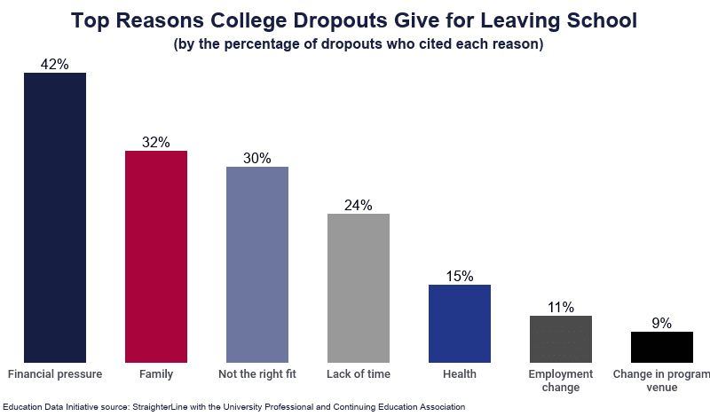

<https://whattobecome.com/blog/college-dropout-rate/#:~:text=According%20to%20the%20latest%20findings,with%20a%207.4%25%20dropout%20rate>.

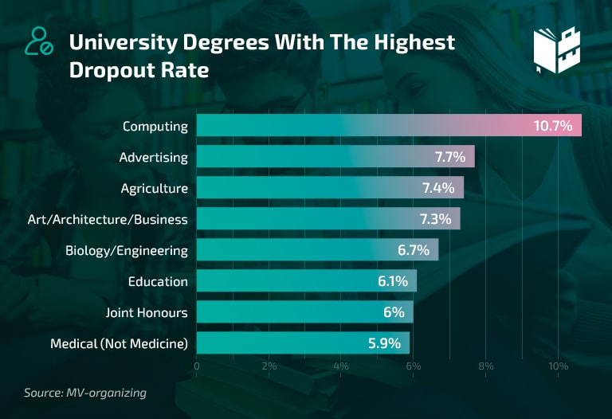

1. **Graduate students Dropout stats in the US :**

<https://www.bestcolleges.com/research/college-dropout-rate/>

<https://www.thinkimpact.com/college-dropout-rates/>

* A college dropout earns 35% less than a college graduate per annum.
* A valued $3.8 billion is lost each year as a result of college dropouts.
* 55% of college students struggle to find financial support for their studies. Consequently, 51% of college dropouts drop out because of the lack of money.
* 79% of the students delay their graduations due to financial difficulties.
* The average retention rate in American higher education institutions is 71%.
* Of the 57% of students who do not complete four-year colleges within six years, 33% drop out altogether.

At four year institutions, full-time degree students had the following statistics in the 2017/ 2018 academic year:

* The general retention rate was 81%. Colleges and universities with open admissions had a retention rate of 62%. The institutions with an acceptance rate of less than 25% recorded a 97% retention rate.
* The institutions with the lowest acceptance rates (less than 25%) recorded the highest retention rates.
* In the least selective public institutions – with an acceptance rate of higher than 25%, there was a 63% retention rate.
* Public institutions that did not have an open admissions policy recorded a 97% retention rate.
* A 97% retention rate was also seen at private non-profit institutions without an open admissions policy.
* Private non-profit institutions with an open admissions policy recorded a 65% retention rate.
* Overall, private for-profit institutions had a 60% retention rate, with those with open admissions having a 5% lower retention rate.

<https://research.com/universities-colleges/college-dropout-rates#2>

Due to such conditions, the Organization for Economic Co-operation and Development (OECD) ranked the U.S. 19th (out of 28 countries) in graduation rates (National Center for Education Statistics [NCES], 2021).

College dropout rate for students with disabilities show that:

* While 90% of high school graduates with disabilities are expected to be “college-ready,” less than 35% of students graduate from four-year colleges in eight years, and those enrolled in two-year courses fare worse, (Higher Ed Dive, 2017).
* 49% of students diagnosed with ADHD but are not given medication are more likely to drop out (What to Become, 2021).
* 47% of students diagnosed with schizophrenia tend to leave university (What to Become, 2021).
* A third of students diagnosed with depression do not finish their degree (What to Become, 2021).

<https://www.statista.com/statistics/184996/unemployment-rate-of-high-school-graduates-and-dropouts/>

<https://www.collegeatlas.org/college-dropout.html>

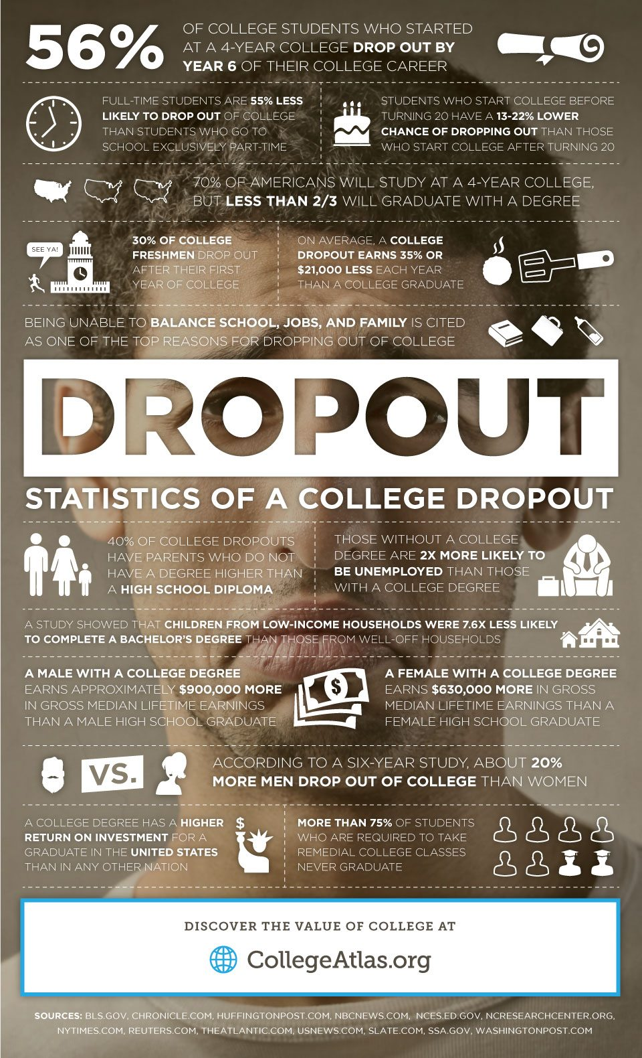

1. **Graduate students Dropout stats in Portugal:**

<https://www.theportugalnews.com/news/portugals-school-dropout-rate-among-highest-in-europe/34555>

At 17.4 percent Portugal has the fourth highest rate of early school abandonment in the European Union according to new figures from Eurostat, but, while the result may not be anything to shout about, it also showed the greatest reduction in dropouts when compared to numbers from 2006.

According to the information from the EU’s official statistics office Spain had the worst rate of dropouts, at 21.9 percent, followed by Malta, Romania, Portugal in fourth and Italy completing the top five.

However, on the flip side of the coin, Portugal also showed the greatest reduction in the number of school abandoners in comparison to figures from 2006, having improved from 38.5 percent that year, to 17.4 percent last year, a decrease of almost half.

<https://www.oecd.org/education/education-at-a-glance/EAG2019_CN_PRT.pdf>

<https://www.bing.com/search?q=portugal+graduation+dropout+rate&qs=NWB&pq=portugal+graduation+dropout+ra&sc=9-30&cvid=3703B0A1E63C4199BAA328D4B57CD1CE&FORM=QBRE&sp=1>

• As of 2012, the unemployment rate in Portugal was about 14%, and youth unemployment was about 35%.

• Portugal's 30% overall high school graduation rate is significantly lower than that of Germany, where 89% of its residents complete high school, and the Czech Republic, where 91% graduate.

**List of ED-TECH companies in the world**

[**https://www.edsys.in/best-edtech-companies-around-the-world/#:~:text=The%20Top%2012%201%201%29%20Byju%E2%80%99s%20Located%20in,...%208%208%29%20Dreambox%20Learning%20...%20More%20items**](https://www.edsys.in/best-edtech-companies-around-the-world/#:~:text=The%20Top%2012%201%201%29%20Byju%E2%80%99s%20Located%20in,...%208%208%29%20Dreambox%20Learning%20...%20More%20items)

**1) Byju’s**

Located in Bangalore, India, Byju’s entered the edtech industry in 2011. Byju’s started off as a simple learning platform back then. At present, the edtech startup is known to be one of the established names in the industry, still spreading its presence across the world.

##### ****2) Blackboard****

Founded in 2011, Blackboard is a Washington- based edtech company that is one of the giants in the industry. The company aids educators in providing quality education to students through its enterprise technology and solutions for teaching, learning, and student engagement.

Blackboard is one of the biggest edtech companies with a total valuation of $700 million. Through its services, the company aims to revolutionize the way online learning works.

##### ****3) Coursera****

Based in California, USA, Coursera is a well-known MOOC platform that connects learners with over 150 universities. They offer over 4000 courses across different subject areas, thus helping students acquire the best education at their own pace.

##### ****4) Chegg****

Founded in 2005, Chegg is an online learning platform that provides students a wholeseome learning experience. As of the statistics from 2021, Chegg was reported to have 7.8 million subscribers, which is expected to grow with the latest innovations introduced by the company.

##### ****5) Teachers Pay Teachers****

Teachers Pay Teachers aka TPT is an edtech company created by teachers for teachers to interact with each other, share content and tools for teaching.

##### ****6) Instructure****

Founded in 2008, Instructure is another edtech start up that provides to the teaching community. Instructure combines LMS and MOOC to provide education to students.

##### ****7) Knewton****

Knewton is a New York-based advanced edtech company that focuses on providing a personalized learning experience to learners through adaptive technology.

##### ****8) Dreambox Learning****

Dreambox Learning is an eLearning start up based in Seattle, USA, that makes math learning exciting through adaptive learning technology.

##### ****9) Simplilearn****

Founded in 2010, Simplilearn is one of the few edtech companies that provide professional education. It provides professional certifications to those who complete the courses provided in the portal.

##### ****10) Donorschoose****

Donorschoose is a non-profit edtech company that prioritises practical learning. Through Donorschoose, students get funding from donors for their projects.

##### ****11) Go1****

Go1 is an edtech company based in Brisbane, Australia, founded in 2015. It is a learning platform that comes with a curated learning and development library containing learning materials and tools from some of the best training providers.

##### ****12) Udacity****

Udacity is a popular MOOC platform that offers technology courses. They help professionals attain all necessary tech skills that businesses are looking for in their employees.

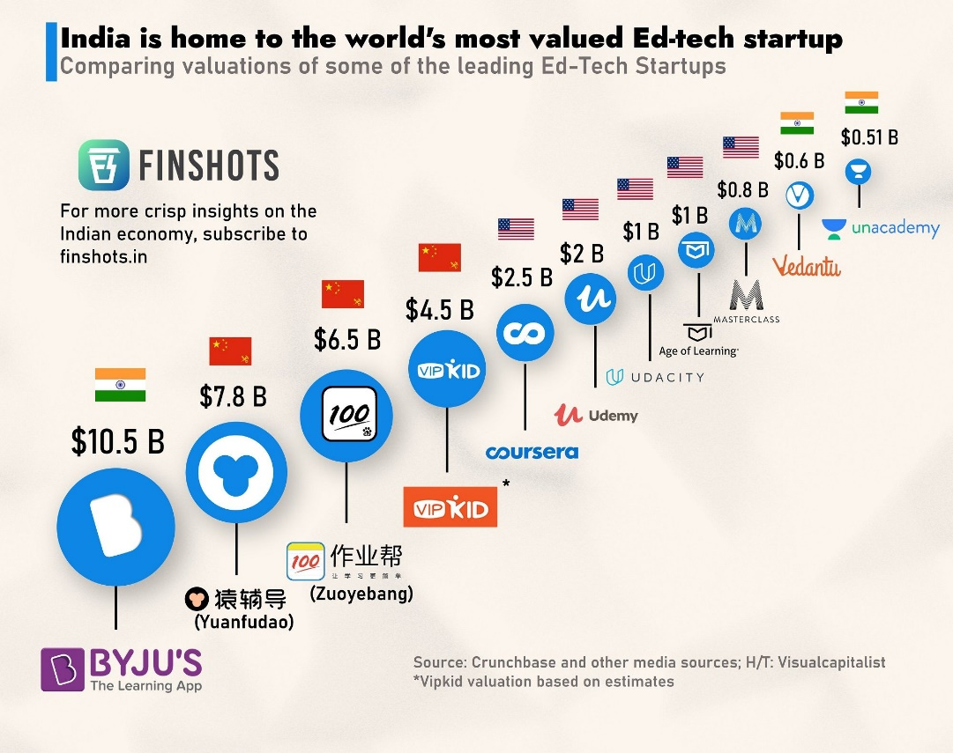

**List of ED-TECH companies in the Portugal**

<https://edtech-europe.educationtechnologyinsights.com/vendors/top-edtech-companies-in-europe.html>

<https://www.bing.com/search?q=List+of+edtech+companies+in+the+Portugal&qs=n&form=QBRE&sp=-1&pq=list+of+edtech+companies+in+the+portugal&sc=10-40&sk=&cvid=B566818A855D4CC2B4EDC2573059C8F7&ghsh=0&ghacc=0&ghpl=>

Only two EDTech are exist in Portugal

* 1. Labseal
  2. Focal point Edtech

**Business Statistics of Ed tech companies**

<https://brandongaille.com/23-edtech-industry-statistics-and-trends/#:~:text=23%20Edtech%20Industry%20Statistics%20and%20Trends%201%20%231.,largest%20in%20the%20world%20today.%20...%20More%20items>

#1. David Bainbridge forecasts that the edtech industry will reach a global value of $252 billion by the year 2020. (Forbes)

#2. Over 138 venture deals in total, U.S.-based edtech companies were able to raise a total of $1.03 billion. Startup companies that focused on the corporate or secondary learning market raised the most money, totaling $593 million in 2016. (Forbes)

#3. The overall education market is one of the largest in the world today. More than $5 trillion is spent globally each year on students in primary, secondary, and corporate learning. (Tech Crunch)

#4. The edtech sector already contributes 1 billion pounds to the economy of the United Kingdom each year. More than 1,000 startups are currently operating in Britain right now, leading the world in total startup numbers. (Tech Crunch)

#5. In 2014, the valuations of the edtech industry in the United States was an estimated $8.38 billion. (Education World)

#6. Investments into the edtech industry in the United States increased by 5 times from 2010-2015. More than $1.1 billion of new investments was put into the K-12 segment of the edtech industry in 2015. (EdSurge Research)

#7. From a global standpoint, edtech investments account for just 2% of the $58.8 billion invested by the VC industry in 2015. That’s an increase from the 0.9% of the market that educational programs received from the VC industry from 1995-2011. (EdSurge Research)

#8. Three of the leading edtech companies employ a free-for-teachers business model to encourage brand exposure and growth. Edmodo, Class Dojo, and Remind account for more than 100 million users worldwide. (EdSurge Research)

#9. The edtech market in North America is expected to continue growing rapidly, with a 9% CAGR forecast through 2019. (Technavio)

#10. Software and services are the largest segment of the edtech industry. In 2014, the market share for this segment was nearly 60% and it will continue to drive the industry forward toward record profits in coming years. (Technavio)

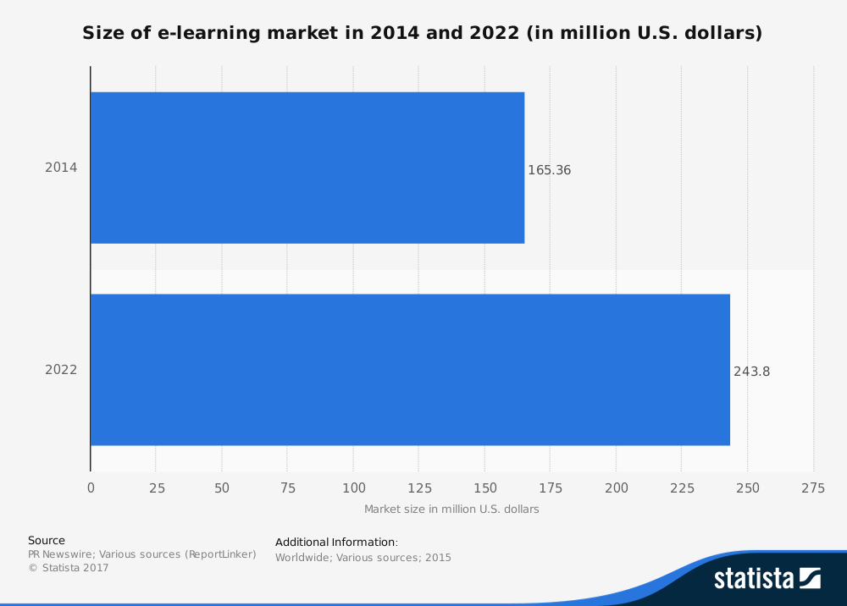

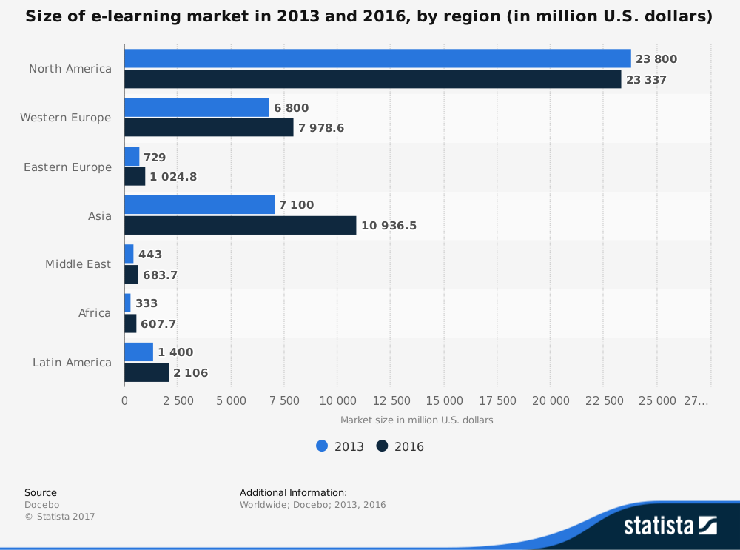

Where the strength of the edtech market will be in the future is China and the Pacific region. 70% of the companies that are raising nine figures for their startups are based in the region. Nearly 1 billion students will be enrolled into educational programs in this region.

Growth within the edtech industry will be far from smooth or stable. As technologies evolve, new opportunities will eclipse the current options that are available. There will be growing pains, but it is difficult to see this industry going anywhere but upward for the foreseeable future.

<https://www.futuremarketinsights.com/reports/edutech-market>

The global **edtech market size** was estimated to be worth **US$ 74.2 Bn** in 2021 and is forecast to grow at a prolific CAGR of **14.5%** during the forecast period between 2021 and 2031, totaling over **US$ 288.4 Bn** by the end of 2031. Growth in the market is driven by rising adoption of **education technologies** across various end use verticals such as academic institutions and business enterprises, increase in the number of **edtech manufacturers**, booming M-education market, and expansion of **digital learning market size.**

<https://www.statista.com/statistics/1086249/edtech-unicorns-worldwide/>

<https://www.grandviewresearch.com/industry-analysis/education-technology-market>

## **Key Companies & Market Share Insights**

Vendors active in the market are focusing aggressively on expanding their customer base and gaining a competitive edge over their rivals. Hence, they pursue various strategic initiatives, including partnerships, mergers & acquisitions, collaborations, and new product/ technology development. For instance, in January 2022, Teachmint Technologies Pvt. Ltd, an online app for students and teachers, has acquired MyClassCampus, (Teachmint Technologies Pvt. Ltd) an ERP platform for educational organizations. This acquisition will let Teachmint expand its offerings in schools and various educational institutions by combining its learning management system (LMS) with the ERP software. Besides, in June 2021, BYJU’S, an EdTech company that provides online tuitions, partnered with Google LLC to make online learning more consistent for both professors and students. This partnership will allow educational institutions to offer a personalized digital platform for classroom organization.Some of the prominent players in the global education technology market include:

* BYJU'S
* Blackboard Inc.
* Chegg, Inc.
* Coursera Inc.
* Edutech
* edX Inc.
* Google LLC
* Instructure, Inc.
* Microsoft
* Udacity, Inc.
* upGrad Education Private Limited